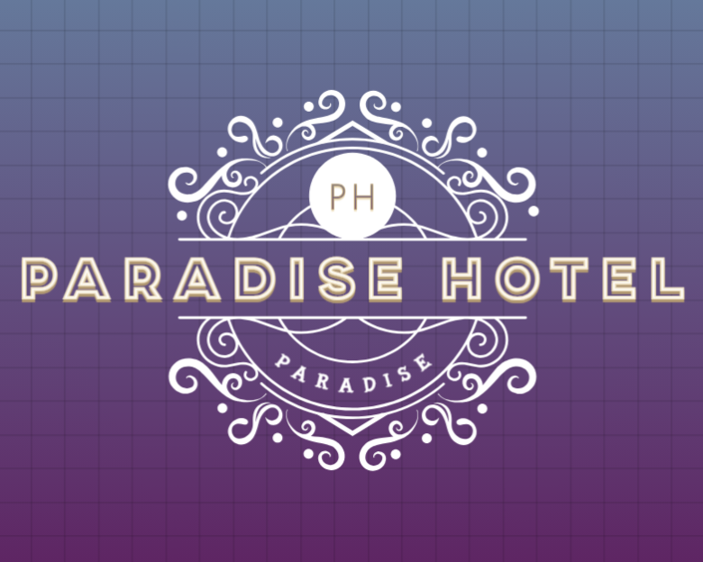

# Documentation File

**Name: Tuba jan**

**Name: Bushra jan**

**Name:** **Aswa Sohail**

**Group members: 3**

**Website name: paradise hotel**

**Teacher name: Sumbul Saleem**

**Campus name: central homeopathic college**

**Class timing: 4:00to 6:00**

# Description:

**“We thought about travelers who love to travel, and it often happens that when you arrive in a city or country, you can ‘t finds a hotel to check in. It can be very disturbing, especially when You're with family and have a lot of luggage. So, we thought, why not create a website where you can make your bookings and arrangements beforehand? We started working on this Project, and we have created a website where you can find all the details about our hotel**

# About us:

**“Hotel Paradise is a magnificent and comfortable accommodation that will make you feel at Home during your travels. Our aim is to provide utmost convenience and comfort, ensuring Every traveler experiences a memorable stay. Our special amenities and hospitality make us a delightful experience. Come and experience heavenly comfort, welcome to Hotel Paradise**